Mia Čarapina

Vierchai

Interface for questions

Technical Specification

Version: | 1.0
Author: | Vierchai
Date: | 6/6/2017

Table of Contents

1. Version Control 3
2. Distribution List 3
3. Abbreviations 3
4. Project description 4
5. Technology 4
5.1. Development Tools 4
6. Wireframes (Storyboards) 4
7. User Interface Specification 4
7.1. Navigation 4
7.1.1. Global 4
7.1.2. Secondary 4
7.1.3. Tertiary 4
7.2. Single page (section) specification 5
7.2.1. Section name (for each section separately) 5
7.2.1. Page name (for each page separately) 5
8. Testing 5
8.1. List of functions tested 5
8.2. Results 5
9. Troubleshooting Guide 6
10. Appendices 6

Version Control
The following is a list all changes made to this document, the person making the change, the new version number and the reason why the change was necessary.

Date | Author | Version | Change Description
3/6/2017 | Renata Tremski | 1.0
4/6/2017 | Iva Nekić
6/6/2017 | Kipras Gabrielaitis

Distribution List
The following list contains the names and organisational details of the people to whom this document has been distributed.

Name | Organisation | Position
Mia Čarapina | Zagreb University of Applied Sciences | Prof.

Abbreviations

The following table contains a list of the terms and abbreviation specific to the project.

Abbreviation | Definition

Project description
Contains short description of the project and project goals.

Web application that enables the user to post questions to a specific audience, collect answers, analyze and archive them.

Technology
A brief description of the underlying technology and versions used by the application, e.g. Coldfusion, Java, PL/SQL, PHP,.Also include frameworks and methodologies used.

HTML5, CSS3, JavaScript, PHP, SQL

Development Tools
This section should be used to document the usage of tools (PHPStorm, Photoshop…).
Photoshop CS4, Notepad++

Wireframes (Storyboards)
Contains wireframes with detailed description.

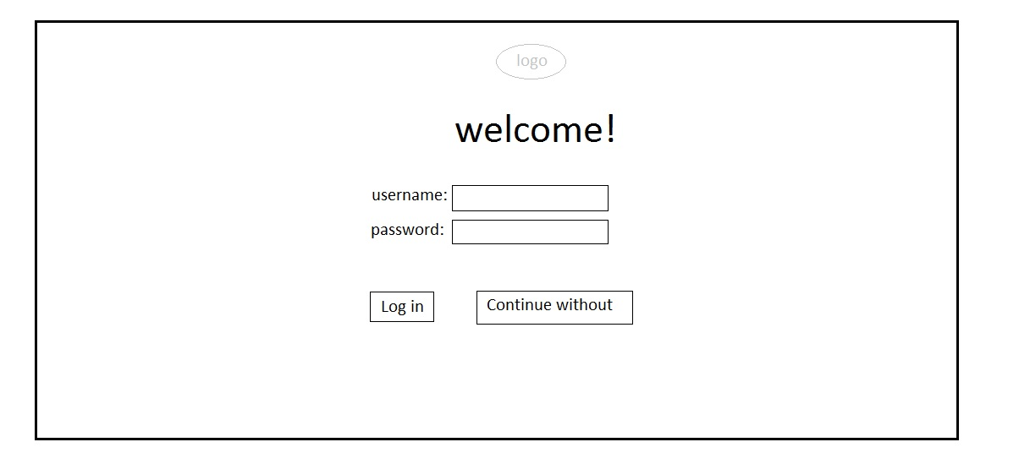
Picture 1: Index page for logging in
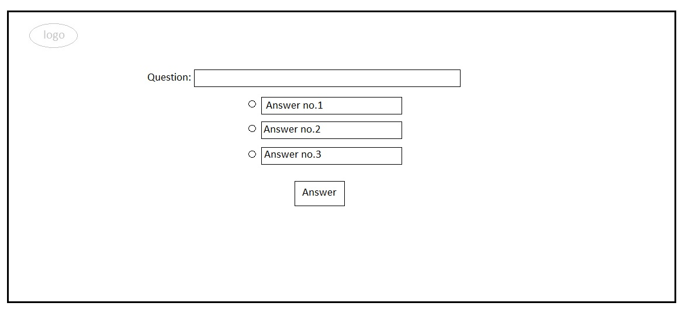
Picture 2: Page for answering questions
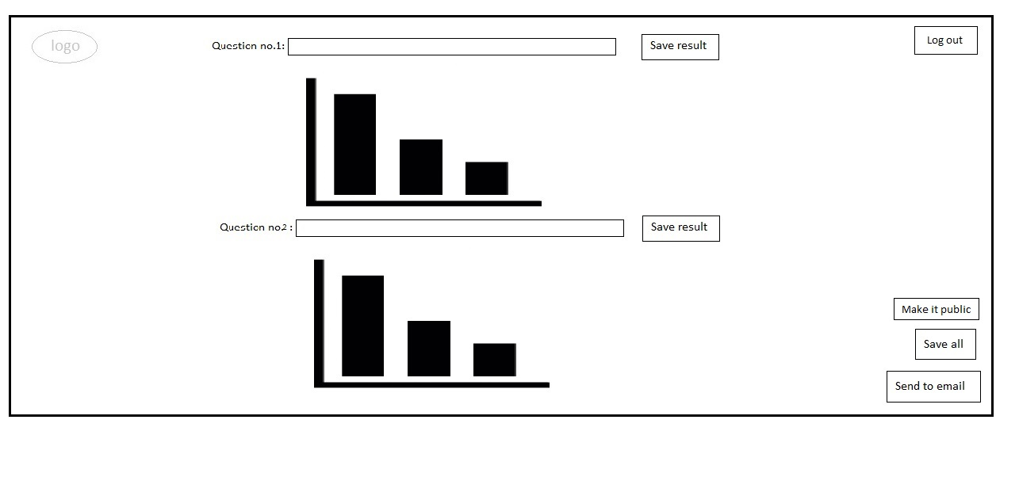
Picture 3: Page for showing results

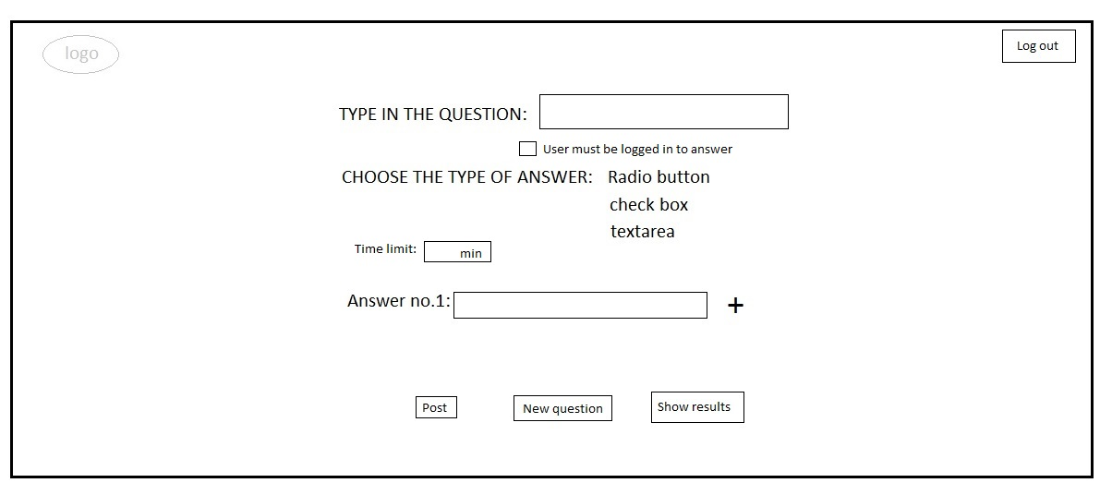
Picture 4: Page for creating questions

User Interface Specification
Describe:

- Navigation:
  - Global navigation (main navigation)
  - Secondary navigation (navigation visible only in specific sections)
  - Tertiary navigation

- Each single page specification

Navigation

Global
Contains textual description or diagrams.

Secondary
Contains textual description or diagrams.

Tertiary
Contains textual description or diagrams.

Single page (section) specification

Index (for each section separately)
INDEX: To post a question the professor needs to log in. Once that is done, the page redirects to the page for posting questions (posting.html).
Depending on the question requirement the student may need to log in to answer the question or continue without logging in.

POSTING: After logging in, user is redirected to this page and have possibility to create a question and choose type of answers, time limitations for answering, define if the user needs to be logged in to access the answer page.

ANSWERING: Depending on the question requirement, user logs in or accesses answering page without providing account information. Once user is(isn't) logged in he can answer the posted question by typing or choosing one of the offered answers.

ANALIZING: After the answers are submitted, professor can access the analyzing page from the posting one by clicking on “show results” which redirects to the analyzing page. These results can be downloaded on computer, sent on email or can be made public for all users.

Posting questions (for each page separately)

Testing

Period:

List of functions tested

No. | Functionality | Goals of testing

Results

No. | Result and comments

Overall result (conclusion):
Describe.

Troubleshooting Guide
Contains the list of known problems that have not been fixed in this version.

Appendices
Contains other important data crucial for the project realization, which were not covered in previous sections.

